# CS-499 Module 3 – Enhancement 1 Assessment

Software Design/Engineering

Erik Wilhelm

erik.wilhelm@snhu.edu

Southern New Hampshire University

Briefly describe the artifact. What is it? When was it created?

The artifact that I selected for this enhancement was my final project for CS-330 Computer Graphics and Visualization in early 2021. The set up for the project was to select 3-4 objects with at least 1 that was comprised of multiple objects and render them using C++ and OpenGL. I then worked on developing the project over the course of the class while working on other development skills that would be incorporated into the final project. I did complete the project within the requirements of the class but I did not complete my intended scope. I had intended on continuing my learning of OpenGL but the class ended and I did not make the time.

Justify the inclusion of the artifact in your ePortfolio. Why did you select this item? What specific components of the artifact showcase your skills and abilities in software development? How was the artifact improved??

I chose this project because I found the understanding and creation of 3D objects very interesting. I have worked many years in construction and Engineering so I have studied and work with CAD software including 3D rendering from a drafting position. I have not been able to understand the programming and code necessary to be able to create the drawings. This project was a perfect supplement to my existing skills as it allowed me to combine my current work in drafting and project management with my school life within Computer Science. This was my first C++ project and it is a language I intend to build additional skills in. The skills that I have shown with the inclusion of this artifact in my portfolio are that I have a solid understanding of creating 2 and 3 dimensional drawings to aid in visualizing and communicating solutions to projects that I am part of. I have shown that I can take existing code and build upon it to create a complete and working solution that meets the expected goals and that has been code reviewed for proper execution, commenting, and security. I can work quickly to solve problems that can arise when working on existing or starting new projects.

The improvements that I made to this project were more entailed than originally anticipated. While researching work that I had completed when selecting artifacts for enhancement I remembered that I had my completed my final project from CS-330 and that I could build upon it to show additional objects and navigation utilities for viewing the 3D world. During my code review I realized that the project would not compile and that it was rendering from a past working solution. I then began to review the files I had and found that I did not have a working solution from the project, but I had images and notes from most of the class.

I started a new project from a sample file that I had which was provided at the start of CS-330 in my downloads folder. I used that file to create a template file and then began rebuilding my code from old projects and images that I had saved. While I worked, I developed incrementally and tested often to ensure that I could compile and run my code. I rebuilt the project to the best of my ability and then worked on enhancements. In the end I was able to create a complete solution that met my expectations and goals. I was able to include and improve existing geometry as well as enhance header, shading and lighting files. Additionally, I built a new texture to match my current counter and located the objects in the world to match my initial intentions more closely.

Did you meet the course objectives you planned to meet with this enhancement in Module Two? Do you have any updates to your outcome-coverage plans?

The goals that I planned for this project was to add to the geometry and add keyboard navigation for moving in the “World” view. I also intended to add to readability and modularity by ensuring that methods were grouped together based on their intended purpose. This artifact met these goals and, contrary to my initial concerns exceeded them.

In this artifact enhancement, I employed strategies for building collaborative environments for a diverse audience by adding inline comments as well as header information. I created a video that showed the existing code and how I intended to enhance it. I designed, developed, and delivered a project that was accompanied by professional quality assessment and video code review that clearly stated my goals and intentions and outcomes. I used software design and engineering mindset to solve the problem of code not compiling initially and to add additional navigation for the world view. I demonstrated that I can and have used well founded and innovative skills by creating a template and ensuring that the code is modular and usable by many different audiences. I demonstrated that I have a security mindset by performing an initial code review, removing unused variables and calculations and applied inline commenting and notes for reference. .

I was able to add to the codes usage by creating a template file that will help start projects in the future and that includes many shape and shader files as well as proper pathing for libraries. This will speed up initial project startup and aid in creation of other library files as needed. The code is more secure because I updated my development and operating system software prior to starting the new project and now it is operating in the most up to date versions. I created secure code that can be communicated and resourced by ensuring that it was clearly commented, free of unused calculations and variables, and I tested the code incrementally as I developed it.

Reflect on the process of enhancing and/or modifying the artifact. What did you learn as you were creating it and improving it? What challenges did you face?

I began this project and quickly realized that I was going to have to manage time and expectations very closely. I was cautiously optimistic when I started this project because it was a very interesting class and I remember it as being a great balance of reward and disappointment. This artifact was no different. I had to spend a lot of time initially, reading the learn open GL webpages and referring to class documentation to remind myself of the general setup and key library locations. This project was only way to start my ePortfolio because it made me get back into a development mindset starting where I start from the beginning with a plan and flow diagram and then working to complete that plan and modify if it was necessary. I had to reteach myself about the pathing of libraries and refresh myself with C++ and OpenGL. This project taught me that as long as I use the tools that I have developed while in the Computer Science program such as time and project management and incremental development as well as using algorithmic thinking I will meet and exceed my goals.

Reference:

<https://learnopengl.com/Introduction>

Object Creation Selection

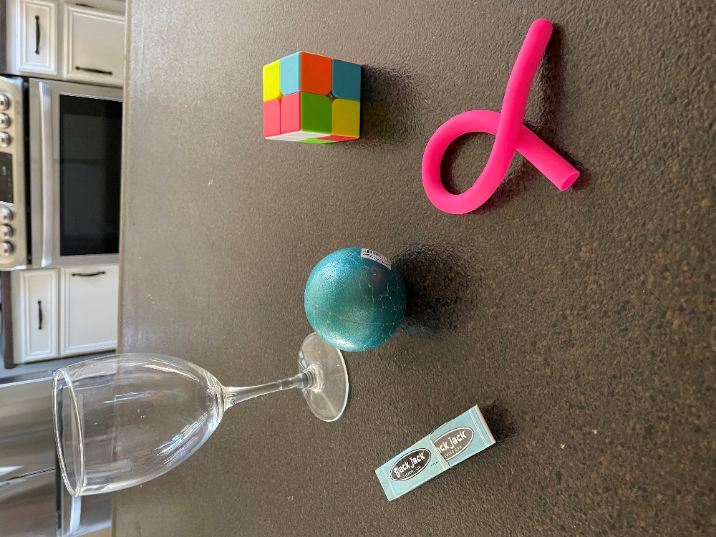

Enhancement Outcome Image

Enhancements include: Software and IDE update, Image creation and modifications, template creation, “World” view (shown) keyboard navigation, and adding code.

Outcomes: Better image creation, updates to colors, textures, showing lighting reflection, modularity using templates and block coding, added readability using commenting and removing unused code and variables, increased code security using testing throughout code, updating software, and removing unused code and comments.

